Introduction to Internet
What is a Network?
A network is a group of two or more computers connected through communication channels to share data, resources, and services.
Network devices like routers, switches, hubs, and bridges help in communication between systems.
What is Internet?
The Internet is a global network connecting millions of computers worldwide.
It uses the TCP/IP protocol suite for communication and provides services such as email, web browsing, file transfer, video streaming, and online communication.
Working of Internet
- The Internet works using TCP (Transmission Control Protocol) and IP (Internet Protocol).
- IP assigns addresses and manages routing.
- TCP ensures reliable data transmission by dividing messages into packets and reassembling them correctly at the destination.
Uses of Internet
- E-mail: Sending electronic messages.
- Web Chat: Real-time online conversation.
- World Wide Web: Accessing linked information using browsers.
- E-commerce: Buying/selling goods online.
- Internet Telephony: Voice communication over the Internet.
- Video Conferencing: Communication using video and audio.
Common Internet Terms
- Web Browser: Software to access the web (e.g., Chrome, Edge, Firefox).
- Webpage: A single document on the web, created using HTML and CSS.
- Website: A collection of related web pages under one domain.
- Search Engine: Finds information on the web (e.g., Google, Bing).

Difference Between Network and Internet
Network | Internet
Connects few computers locally | Connects networks globally
Used within limited area | Worldwide system

Advantages
- Easy access to vast information.
- Entertainment and communication.
- Online shopping and e-learning.
- Latest news and updates.
Disadvantages
- Internet addiction.
- Cybercrimes and hacking.
- Reduced physical and social interactions.
The Network Edge in Computer Networks
The Network Edge refers to the end points or devices that are connected to the outer boundary of the Internet or any network.
It is the part of the network where users and applications interact with the network services.

Components of the Network Edge
- End Systems (Hosts)
  - These are the devices used by users to access the network.
  - Examples: Computers, Laptops, Smartphones, Servers, IoT devices.
  - End systems run applications like web browsers, email, video streaming, etc.
- Access Networks
  - These are the communication links that connect end systems to the first router in the network (the edge router).
  - Examples:
    - Home Networks (Wi-Fi, Ethernet)
    - Mobile Networks (4G/5G)
    - Institutional Networks (LANs in schools, offices)
    - DSL, Cable Networks, Fiber Connections
- Edge Routers / Access Routers
  - These are the first routers that connect the end systems to the core of the Internet.
  - They manage traffic between local networks and the wider Internet.

Functions of the Network Edge
- Acts as the entry and exit point for data into the Internet.
- Handles data transmission between end systems and the core network.
- Performs traffic control, security checks, and load balancing.
- Provides reliable communication for applications like email, web browsing, and streaming.
WhatIsaProtocol?
Aprotocol defines the format and the order of messages exchanged between two or more communicating entities, as well as the actions taken on the transmission and/or receipt of a message or other event.
The Network Core in Computer Networks
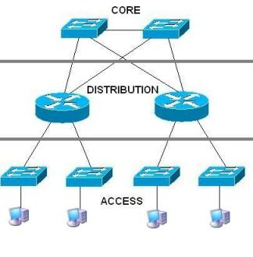
Definition
The Network Core is the central part of the Internet, made up of a mesh of packet switches and communication links that connect end systems. It provides essential services to the network edge, such as routing and forwarding.
It forms the “backbone” of the Internet, ensuring that packets move efficiently between different network edges.

Main Functions of the Network Core
- Routing:
Determines the best path for data packets to travel from sender to receiver.
- Forwarding:
Moves data packets from one router to the next toward the destination.
- Congestion Control:
Manages heavy traffic to prevent delays and data loss.
- Reliability:
Ensures that packets reach the correct destination, even if some links fail.

Structure of the Network Core
- Routers: Devices that receive and forward data packets between networks.
- Fiber-optic Links: High-speed physical connections between routers.
- Backbone ISPs: Large Internet Service Providers (like Airtel, Jio, AT&T) maintain the main Internet infrastructure.

Features of the Network Core
- High-speed data transmission.
- Provides multiple paths between networks for reliability.
- Uses packet switching to efficiently send data across the network.
- Does not directly interact with end-users (unlike the network edge).
Two Approaches for Data Transmission
- Circuit Switching
- Packet Switching

1. Packet Switching
- End systems exchange messages, which are divided into smaller packets.
- Packets travel through routers and links, transmitted at the full link rate.
- Most routers use store-and-forward transmission, meaning they must receive the entire packet before sending it forward.
- If multiple packets arrive simultaneously, they wait in output buffers, causing queuing delays or packet loss if buffers are full.
- Each router uses a forwarding table to decide the next hop based on the packet’s destination IP address.
- Routing protocols (like shortest path algorithms) automatically update these tables.

2. Circuit Switching
- A dedicated communication path is reserved between end systems for the entire session.
- Used in telephone networks.
- Three phases:
  - Setup phase – Establish the circuit
  - Data transfer phase – Exchange data
  - Teardown phase – Release resources
Multiplexing in Circuit Switching:
- FDM (Frequency Division Multiplexing): Each connection gets a separate frequency band.
- TDM (Time Division Multiplexing): Time is divided into slots; each connection uses one slot per frame.
Delay, Loss, and Throughput in Packet-Switched Networks
When a packet travels from the source host to the destination host through several routers, it experiences different kinds of delays at each node. The total time a packet spends at a single router or node is called the nodal delay. The main types of delays are processing delay, queuing delay, transmission delay, and propagation delay.

Types of Delay
When a packet is sent from an upstream node to a downstream node through a router, the total delay at the router consists of the following components:
1. Processing Delay
- It is the time required by a router to examine the packet’s header and decide where to forward the packet.
- It also includes the time needed to check for bit-level errors that may have occurred during transmission.
- Processing delays are very small — usually in microseconds or less — because routers are designed for high-speed packet processing.
- After this, the packet is placed in the appropriate output queue.

2. Queuing Delay
- After processing, packets wait in the output queue for their turn to be transmitted onto the link.
- This waiting time is called queuing delay, and it depends on the number of packets already waiting in the queue.
- If the queue is empty, the queuing delay is almost zero. But if the network is congested, the delay can increase significantly.
- Queuing delays can vary from microseconds to milliseconds and are highly unpredictable, depending on the traffic load at that moment.

3. Transmission Delay
- It is the time required to push all bits of the packet onto the link.
- If the packet length is L bits and the link transmission rate is R bits/sec, then
$$d_{trans}=\frac{L}{R}$$
- For example, on a 10 Mbps link, a 1,000-bit packet will take 0.1 milliseconds to transmit.
- Transmission delay depends on packet size and link bandwidth.

4. Propagation Delay
- Once bits are transmitted, they propagate through the physical link to the next router.
- The propagation time depends on the distance between routers and the propagation speed of the medium (such as fiber or copper).
- It is given by
$$d_{prop}=\frac{d}{s}$$
where d is the distance and s is the propagation speed (about 2×10⁸ m/s in optical fiber).
- Propagation delays are usually on the order of milliseconds.

Total Nodal Delay
The total delay experienced by a packet at a single node is:
$$d_{nodal}=d_{proc}+d_{queue}+d_{trans}+d_{prop}$$

Queuing Delay and Packet Loss
- Traffic intensity (La/R) determines the level of congestion in a queue:
  - L = average packet length (bits)
  - a = average packet arrival rate (packets/sec)
  - R = transmission rate (bits/sec)
- As traffic intensity → 1, the average queuing delay increases rapidly. Even a small rise in intensity can cause a large increase in delay.
- In real routers, the queue capacity is finite. When the buffer becomes full, new incoming packets cannot be stored and are dropped — this is known as packet loss.
- Thus, queuing delay and packet loss depend on the traffic load and buffer size of routers.

End-to-End Delay
When a packet travels through multiple routers from the source to the destination, the total end-to-end delay is the sum of nodal delays over all routers along the path.
If there are N−1 routers between source and destination, the total delay is approximately:
$$d_{end-to-end}=N(d_{proc}+d_{queue}+d_{trans}+d_{prop})$$
This total delay determines how long it takes for a packet to travel from sender to receiver.

Throughput in Computer Networks
Throughput represents how much data can be successfully transmitted from the source to the destination over a network within a given time period. It is measured in bits per second (bps), Mbps, or Gbps.
- Instantaneous Throughput: The data transfer rate at a specific moment in time.
- Average Throughput:
$$\text{Throughput}=\frac{F}{T}$$
where F = total bits transferred, and T = total transfer time.
Example:
If Host A sends a file of size F bits to Host B through two links of rates Rₛ and R꜀, then
$$\text{Throughput}=min⁡(R_{s},R\text{꜀})$$
That means the bottleneck link (the link with the lowest rate) determines the overall throughput.
For N links between the server and client,
$$\text{Throughput}=min⁡(R_{1},R_{2},…,R_{N})$$

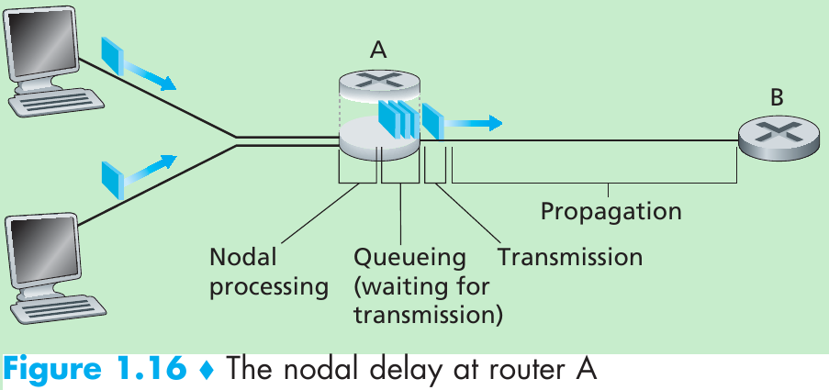
Reference Models
i) OSI Model
The OSI model is based on a proposal developed by the International Standards Organization (ISO). The model is called the ISO OSI (Open Systems Interconnection), which allows different systems to communicate.
An open system is a set of protocols that allows any two different systems to communicate regardless of their underlying architecture.
The purpose of the OSI model is to show how to facilitate communication between different systems without requiring changes to the logic of the underlying hardware and software.
The OSI model is a layered framework for the design of network systems that allows communication between all types of computer systems.
It consists of seven layers:
- Physical Layer
- Data Link Layer
- Network Layer
- Transport Layer
- Session Layer
- Presentation Layer
- Application Layer
Fig: The interaction between layers in the OSI model
i) Physical Layer
The physical layer is responsible for the movement of individual bits from one node to the next.
- The physical layer is required to carry a bit stream over a physical medium.
- It deals with the mechanical and electrical specifications of the interface and transmission medium.
Responsibilities of Physical Layer:
- Physical characteristics of interfaces and medium: Defines the characteristics of the interface between devices and transmission medium.
- Physical topology: Defines how devices are connected to make a network.
- Transmission mode: Defines the direction of transmission (simplex, half-duplex, or full-duplex).
ii) Data Link Layer
The data link layer is responsible for moving frames from one node to the next.
A frame is a series of bits that form a unit of data.
Responsibilities of Data Link Layer:
- Framing: Divides the stream of bits into manageable data units called frames.
- Physical addressing: Adds physical (link) address of sender and receiver in each frame.
- Flow control: Prevents sender from overwhelming the receiver.
- Error control: Detects and retransmits damaged or lost frames; removes duplicates.
- Access control: Determines which device has control over the link when multiple devices share the same medium.
iii) Network Layer
The network layer is responsible for source-to-destination delivery of packets across multiple networks (links).
It delivers individual packets from source host to destination host.
Responsibilities of Network Layer:
- Logical addressing: Adds logical (IP) addresses of sender and receiver in the packet header.
- Routing: Determines the best path for data to travel through routers or switches across networks.
iv) Transport Layer
The transport layer is responsible for process-to-process delivery of the entire message.
A process is an application program running on a host.
Responsibilities of Transport Layer:
- Service-point addressing: Ensures data delivery to a specific process (port) on the destination computer.
- Segmentation and reassembly: Divides messages into segments and reassembles them at the destination.
- Connection control:
  - Connectionless: Treats each segment as an independent packet.
  - Connection-oriented: Establishes a connection before transferring data and terminates it after completion.
v) Session Layer
The session layer is responsible for dialog control and synchronization.
It acts as the network dialog controller that establishes, maintains, and synchronizes the interaction among communicating systems.
Responsibilities of Session Layer:
- Dialog control: Allows two systems to enter into a dialog (half-duplex or full-duplex).
- Synchronization: Adds checkpoints or synchronization points to data streams.
Example:
If a 2000-page file is sent, checkpoints can be added every 100 pages. In case of a crash during page 523, only pages 501–523 need to be resent.
vi) Presentation Layer
The presentation layer is responsible for translation, compression, and encryption.
It ensures proper syntax and semantics of data exchanged between systems.
Responsibilities of Presentation Layer:
- Translation: Converts data from sender-dependent format to a common format and back.
- Encryption: Ensures privacy by transforming data into an unreadable format during transmission.
- Compression: Reduces data size for efficient multimedia transmission (text, audio, video).
vii) Application Layer
The application layer provides services to the user — human or software — for accessing the network.
It offers user interfaces and supports services like email, remote file access, file transfer, shared databases, and other distributed information services.
Services provided by the Application Layer:
- Network Virtual Terminal: Allows a user to log on to a remote host via software terminal.
- File Transfer, Access, and Management (FTAM): Enables users to read, modify, retrieve, or manage files remotely.
- Mail Services: Provides the foundation for email forwarding and storage.
- Directory Services: Offers distributed databases and access to global information about various objects and services.
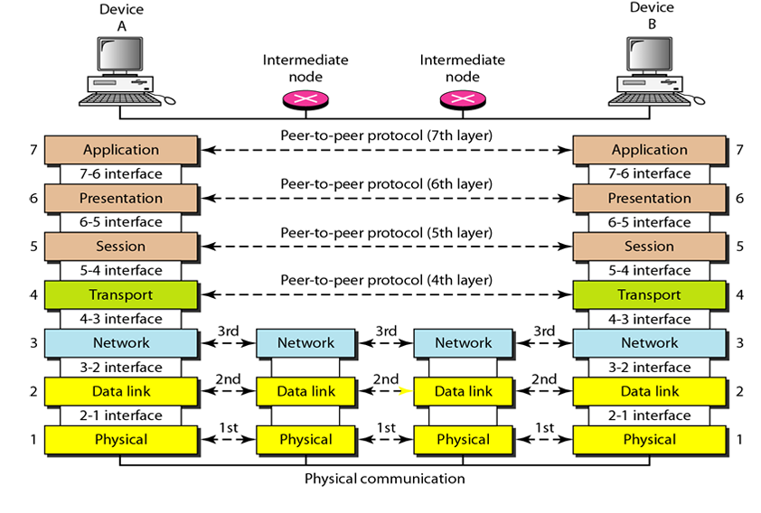
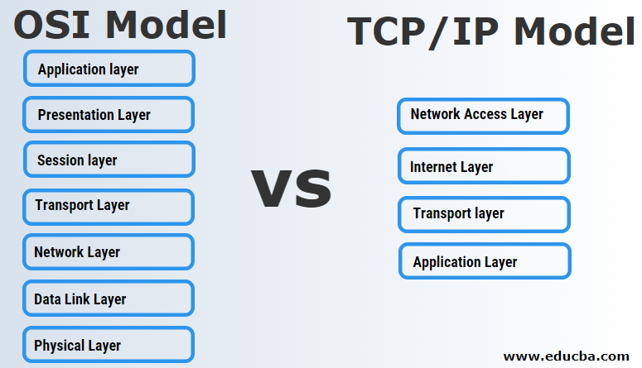
TCP/IP Model
The TCP/IP model is a framework used to describe how data is transmitted over a network. It organizes communication protocols into four layers — Application, Transport, Internet, and Network Access.
Unlike the OSI model with seven layers, TCP/IP is simpler and widely used in modern Internet systems.
Role of TCP/IP
TCP/IP ensures that data sent from the sender reaches the receiver safely and correctly.
Data is divided into packets, which travel independently and are reassembled at the destination, ensuring error-free and complete communication.
Layers of TCP/IP Model
1. Application Layer
- Closest to the user; interacts with applications like web browsers or email clients.
- Acts as a bridge between software and the network.
- Supports protocols such as HTTP (web), FTP (file transfer), SMTP (email), and DNS (domain resolution).
- Handles data formatting, encryption, and session management.
2. Transport Layer
- Ensures reliable, ordered data delivery between devices.
- Uses two main protocols:
  - TCP (Transmission Control Protocol): Reliable and error-checked (used for web pages, downloads).
  - UDP (User Datagram Protocol): Faster but unreliable (used for video calls, online games).
3. Internet Layer
- Responsible for routing and addressing data across multiple networks.
- Uses IP (Internet Protocol) to assign unique IP addresses.
- Handles packet forwarding, fragmentation, and path selection to reach the destination.
4. Network Access Layer
- The lowest layer; manages the physical connection (wired or wireless).
- Transfers data over hardware like cables, switches, and Wi-Fi.
- Uses MAC addresses, creates frames, and checks for errors during transmission.
Example Networks
Computer networks can be classified based on their geographical coverage, purpose, or architecture. Some common example networks are:
1. Local Area Network (LAN)
- Covers a small area such as a home, school, or office building.
- High data transfer rate and low cost.
- Example: College computer lab or office network using Ethernet/Wi-Fi.
2. Metropolitan Area Network (MAN)
- Covers a city or large campus.
- Connects multiple LANs together.
- Example: Network connecting different branches of a university in a city.
3. Wide Area Network (WAN)
- Covers a large geographical area, often a country or continent.
- Uses public transmission systems like telephone lines, satellites, or fiber optics.
- Example: The Internet is the largest WAN.
4. Personal Area Network (PAN)
- Covers a small area around an individual, typically within 10 meters.
- Used for connecting personal devices such as smartphones, laptops, and Bluetooth headsets.
- Example: Bluetooth or hotspot connections.
5. Wireless Local Area Network (WLAN)
- Similar to LAN but wireless; uses radio waves for data transmission.
- Example: Wi-Fi network in homes or cafes.
6. Virtual Private Network (VPN)
- Provides secure communication over public networks.
- Commonly used by organizations for remote access.
- Example: Employees accessing company servers securely from home.
https://www.geeksforgeeks.org/computer-networks/types-transmission-media/

